Project Description:
University timetabling is a yearly battle with many hours and resources dedicated to getting it right. The University of Edinburgh Timetabling department has tasked us with exploring some avenues for future improvements to the timetable and its structure. Our group has decided tackling questions within the TIME set of scenarios that were laid out to us. Specifically, we will be focusing on a reduction in core hours, maintaining a lunch period in the time frame of 12pm-2pm, minimizing clashes and an overall reduction in the idle time for rooms across all campuses.
Targets:
- A Reduction in core hours from 9am-6pm to 9am-5pm.
Stretch Goal: Reducing core hours as far as possible with minimal negative impact on other areas of timetable structure and integrity.
- Maintaining the existence of a lunch break for all students with at least 4 hours of contact time in a day.
Stretch Goal: Lunch breaks structured in a way to minimise the overloading of facility capacities.
- Minimizing clashes at a programme level where possible (including penalising solutions for the introduction of clashes).
Stretch Goal: Minimizing clashes at an individual student level.
- A reduction in idle times for rooms across all campuses, notably lectures theatres at the Kings Buildings campus are idle for much of the week.
Stretch Goal: Have all rooms hit the 75% usage target where possible.
The success of the project will measured by the extent at which we are able to succeed in the targets laid out while the stretch goals will help to measure how far we have succeeded beyond this.
To facilitate the development of a successful model some key steps that we will be taking include:
- Initially optimizing the original timetable at its 9am-6pm cores hours initially to ease the computational burden once we begin to reduce the core hours.
- Modelling/timetabling the Veterinary and Medical Schools separately as their programmes are almost completely separated from the rest of the population.
  - This will also provide a secondary benefit of being a quick way to test the viability of our approach.
The modelling approach is likely include a combination of Constraint Programming to capture the more abstract constrains and Mixed Integer Programming to complete a bulk of the more straightforward computations with mathheuristics used in this stage to lighten this computational burden. This approach being inspired by the methodology of Lamas-Fernandez, Matrinez-Sykora and Potts (2021) [1] as part of their win in the 2021 International Timetabling Competition.
From further literature review we are also considering the implementation of a number of novel techniques. From the model presented by Aygül et al. (2025) [2] we have interest in utilising the common triples and course splitting considerations. We will also be looking into Particle Swarm Optimization as laid out by Chen and Shih (2013) [3]. More broadly the overarching class of Genetic Algorithms, Alghamdi et al (2020) [4], shows promise for efficient solving in this problem area. This is however subject to change as the project evolves and develops over its course.
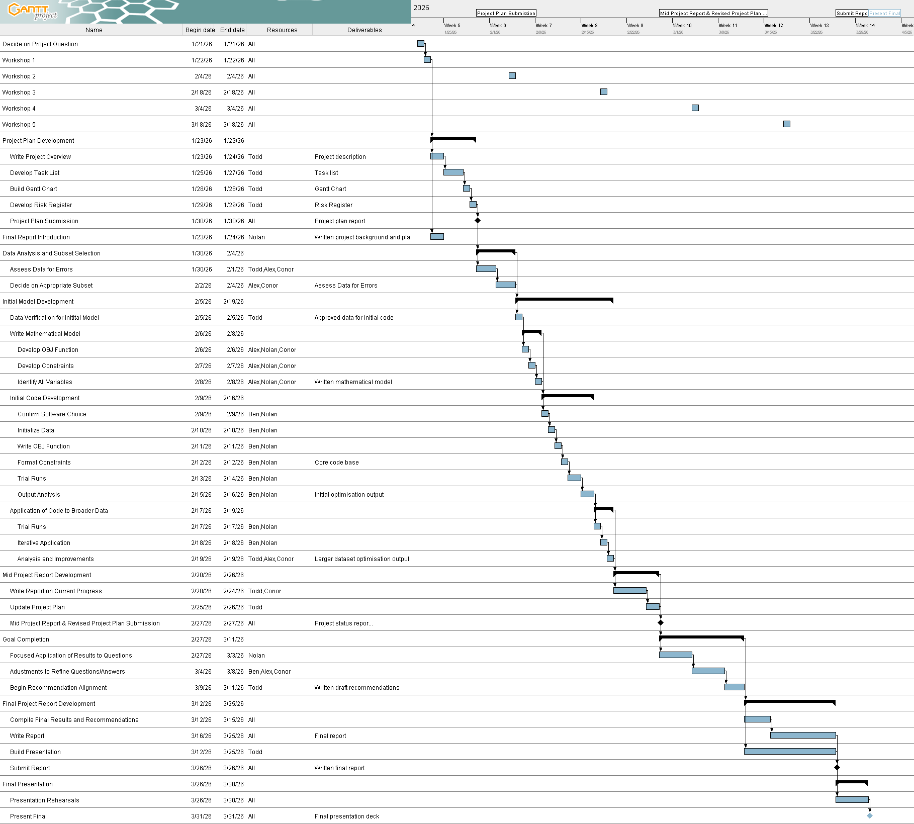

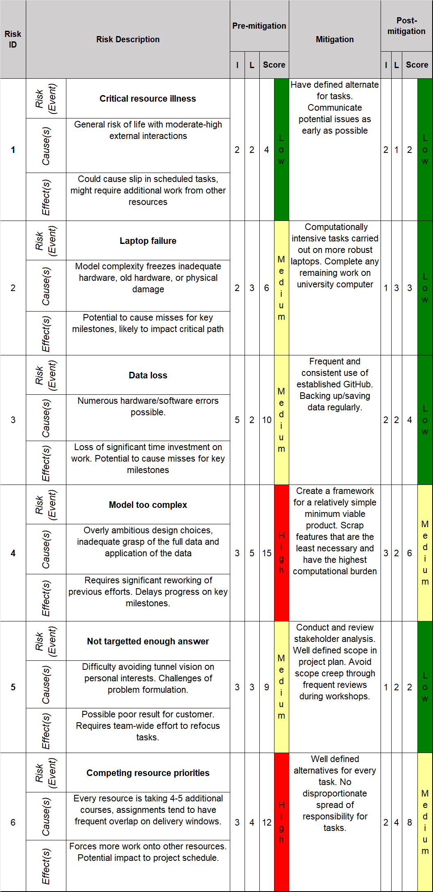
Appendix:
[1] Lamas Fernandez, C., Matrinez-Sykora, A., Potts, C. (2021), Scheduling Double Round-Robin Sports Tournaments, ITC2021.
[2] Aygül, Ö., Hellgren, T., Azizi, S., & Trapp, A. C. (2025), A predict-and-prescribe framework for dynamic course scheduling toward strategic university scaling, Omega, 103406.
[3] Chen, R., Shih, H. (2013). Solving University Course Timetabling Problems Using Constriction Particle Swarm Optimization with Local Search, Algorithms, 6(2), Available at: Solving University Course Timetabling Problems Using Constriction Particle Swarm Optimization with Local Search (Accessed 02/02/2026).
[4] Alghamdi, H., Alsubait, T., Alhakami, H., Baz, A. (2021), A Review of Optimization Algorithms for University Timetable Scheduling, Engineering, Technology & Applied Science Research, 10(6), Available at: A Review of Optimization Algorithms for University Timetable Scheduling | Engineering, Technology & Applied Science Research (Accessed 03/02/2026).

